1. In TCP, When a segment carries a combination of data and

control information, it uses a

A. Port Number

**B. Sequence Number**

C. Segment Number

D. ACK Number

2. In the Internet model, the port numbers are

A. **16-bit integers**

B. 18-bit integers

C. 20-bit integers

D. 22-bit integers

**3.** The ports ranging from 1024 to 49,151 are called

**A. Registered ports**

B. Well-known ports

C. Dynamic ports

D. Data Ports

4. TCP segments need not be of equal size.

1. **True**
2. False

5. To establish TCP connection, at least four control segments are required.

1. True
2. **False**

6. Suppose Host A sends one segment with sequence number 38 and 4 bytes of data over a TCP connection to Host B. In this same segment the acknowledgment number is not necessarily 42.

* 1. **True**
  2. False

7. Suppose Host A is sending Host B a large file over a TCP connection. The number of unacknowledged bytes that A sends can exceed the size of the receive buffer.

1. True
2. **False**

8. If HLEN in TCP is 1100, the number bytes of option are

20

**18**

12

48

9. In TCP, the sending and receiving buffers must be of equal size

True

**False**

10. In receiving buffer, the acknowledged bytes are stored.

**True**

False

11. The sequence number for each segment is the total number of data bytes carried in that segment.

**False**

True

12. In TCP pseudo header, the header length is used to calculate the checksum.

**False**

True

13. SYN segment has the valid 32-bit window size.

True

**False**

14. How many time did TCP Reno experience loss with timeout ? (Assume initial ssthreshold value is 8)

1. 1 times
2. **2 times**
3. 3 times
4. No timeout event

Ans : @ 14,39

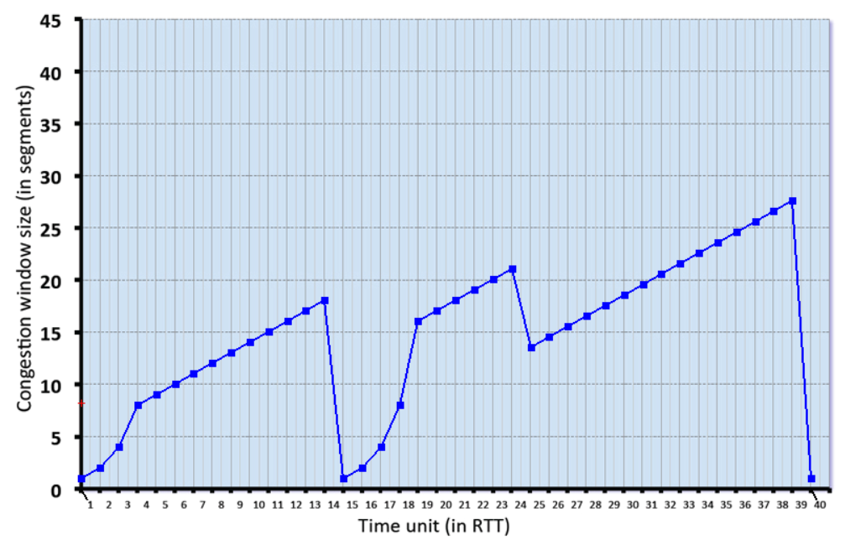

15. Which one of the following is a true statement about TCP?   
(a) TCP is a routing protocol used throughout the Internet.

(b) TCP establishes a connection between two end - hosts using a 2-way handshake scheme.

(c) **TCP learns of congestion via packet loss or variations in delay.**

(d) If the SYN packet sent by a TCP source is lost, the connection is closed.

16. Which of the following statements is true about TCP?   
(a) TCP segments can only be lost when router queues overflow.

(b) **There is no performance benefit to having a window size larger than the receiver window size.**

(c) The received sees duplicate ACKs (with the same sequence number) only when a packet   
is lost.

(d) A receiver reduces the advertised window size in response to congestion

17. in TCP, data cannot be transmitted if the device is in FIN-WAIT 1 state.

(i) True

(ii) **False**

18. For each of the retransmitted packets, separate RTO timer is started.

(i) True

**(ii) False**

19. Choose the in-correct option

**(i) rwnd controls the congestion in the network**

(ii) Timeout indicates severe congestion in the network

1. Slow start phase has faster growth
2. In bidirectional communication, four windows are maintained

20. Segment that has FIN with ACK shows the piggybacking approach

1. **False**
2. True

21. Fast retransmission is possible after receiving of out-of-order segment with sequence number greater than the expected sequence number.

**(i) True**

(ii) False

22. Out-of-order segments are reordered by the network layer.

(i) True

**(ii) False**

23. If the ACK segment is lost and RTO timer is expired, then retransmitted segment is accepted by the receiver.

(i) True

**(ii) False**

24. In congestion avoidance phase, cwnd size is incremented by one after each segment is acknowledged.

**(i)False**

(ii)True

25. After half closing the connection from client to server, the transmission of ACK from the client is permitted.

**(i)True**

(ii) False

26. TCP Control Packets do not consume sequence numbers.

(i) True

(ii) **False**

27. In TCP, most of the flags can be used together in a segment.

**(i) False**

(ii) True

28. In TCP, it is possible to completely terminate the communication in both directions.

**(i) True**

(ii)False

29. Sequence and acknowledge numbers refer to a segment number.

(i) True

**(ii) False**

30. In TCP, it is possible to have 60 bytes for padding and options.

(i) True

**(ii) False**